**1. Write a Java program to convert a given integer (in seconds) to hours, minutes andseconds.**

**Test Data :**

**Input seconds: 25300Expected**

**Output:**

**There are:**

**H:M:S - 7:1:40**

//Task_1.java

|  |
| --- |
| import java.util.Scanner; //importing Scanner class for taking user input  class Task_1{  public static void main (String args[]){  //data type declaration  int seconds,h,m,rm;  Scanner obj=new Scanner(System.in);  System.out.println("Input Seconds : "); //message for display  seconds=obj.nextInt(); //25300 // taking user input    //calculation of converting seconds in h:m:s  h=seconds/3600; //h=7  rm=seconds%3600; //rm=100  m=rm/60; //m=1  seconds=rm%60;    //print the expected output  System.out.println("There are :");  System.out.println("H:M:S - " +h+":"+m+":"+seconds );    }  } |

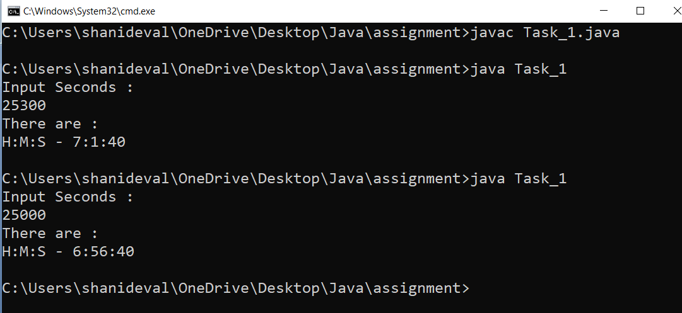

**2. Write a Java program to convert a given integer (in days) to years, months and days,assumes**

**that all months have 30 days and all years have 365 days.**

**Test Data : Input no. of days: 2535**

**Expected Output:**

**6 Year(s)**

**11 Month(s)**

**15 Day(s)**

//Task_2.java

|  |
| --- |
| import java.util.Scanner; // importing Scanner class for taking user input  class Task_2{  public static void main (String args[]){    //data type declaration  int days,rm,number;  Scanner obj=new Scanner(System.in);  System.out.println("Input no. of days : "); //message for display  days=obj.nextInt(); //2535 // taking user input    number=days/365; //number=6  rm=days%365; //rm=345  System.out.println(number + " Year(s)"); //print the expected output  number=rm/30; //number=11  rm=rm%30; //rm=15  System.out.println(number + " Month(s)"); //print the expected output  number=rm%30; //number=15  System.out.println(number + " Day(s)"); //print the expected output  }  } |

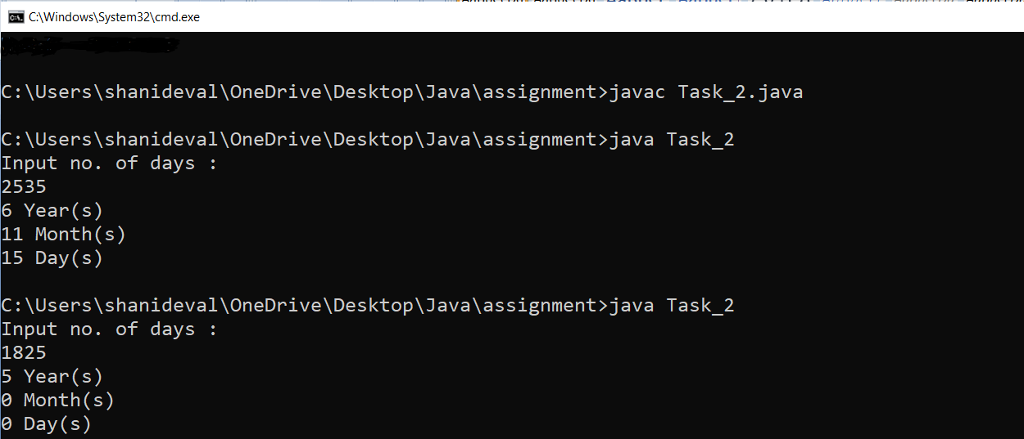

**Q3. Write a Java program that read 5 numbers and print the average of all values.**

**Test Data :**

**First Number : 4**

**Second Number : 6**

**Third Number: 8**

**Fourth Number : 10**

**Fifth Number : 12**

**Expected Output:**

**Average value of the all numbers: 8.00**

//Task_3.java

|  |
| --- |
| import java.util.Scanner; //importing Scanner class for taking user input  class Task_3{  public static void main (String args[]){    //data type declartion  float num1,num2,num3,num4,num5;  Scanner obj=new Scanner(System.in);  System.out.print("First Number : "); //message for display  num1=obj.nextFloat(); //taking input form user  System.out.print("Second Number : "); //message for display  num2=obj.nextFloat(); //taking input form user  System.out.print("Third Number : "); //message for display  num3=obj.nextFloat(); //taking input form user  System.out.print("Fourth Number : "); //message for display  num4=obj.nextFloat(); //taking input form user  System.out.print("Fifth Number : "); //message for display  num5=obj.nextFloat(); //taking input form user    //average calculation  float avg=(num1+num2+num3+num4+num5)/5;  //expected output  System.out.printf("Average value of all numbers: %.2f", avg);  }  } |

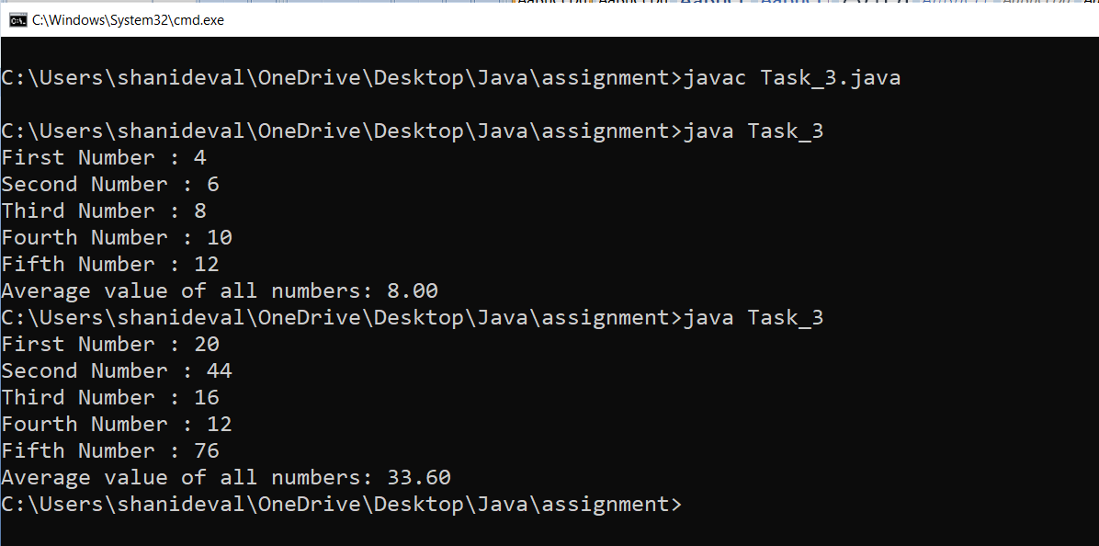

**Q4. Write a Java program to integral quotient and remainder of a division**

**Input numerator : 2500**

**Input denominator : 235**

**quotient = 10, remainder = 150**

//Task_4.java

|  |
| --- |
| import java.util.Scanner; //importing Scanner class for taking user input  class Task_4{  public static void main(String args[]){  //data type declaration  int quotient ,remainder,numerator,denominator;  Scanner obj=new Scanner(System.in);  System.out.print("Input numerator : "); //message for display  numerator=obj.nextInt(); // taking input from user    System.out.print("Input denominator : "); //message for display  denominator=obj.nextInt(); // taking input from user  quotient=numerator/denominator;  remainder=numerator%denominator;  //print the expected output  System.out.println("quotient = "+quotient+ ", remainder = "+remainder);      }  } |

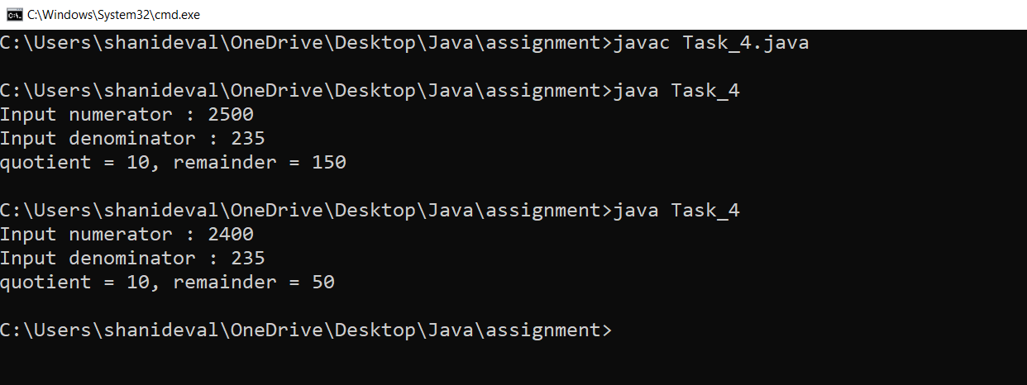

**Q5. Write a java program that converts Centigrade to Fahrenheit.**

**Input a degree in Fahrenheit: 212**

**212.0 degree Fahrenheit is equal to 100.0 in Celsius**

//Task_5.java

|  |
| --- |
| import java.util.Scanner; //importing Scanner class for taking user input  class Task_5{  public static void main (String args[]){    //data type declaration  float c,f;  Scanner obj=new Scanner(System.in);  System.out.println("Input a degree in Fahrenheit : "); //message for display  f=obj.nextFloat(); // taking user input      c=(5*(f-32))/9;  //print the expected output  System.out.println(f+" degree Fahrenheit is equal to "+c +" in Celsius");  }  } |

